# Create an EC2 using the CloudFormation Template

1. Log in to AWS Console > Search for CloudFormation
2. In Cloud Formation console > Click Create Stack

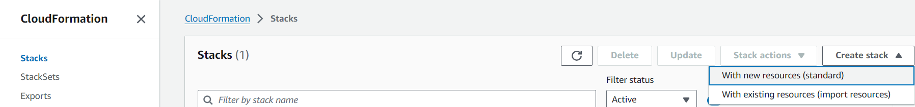

3.Choose the below options

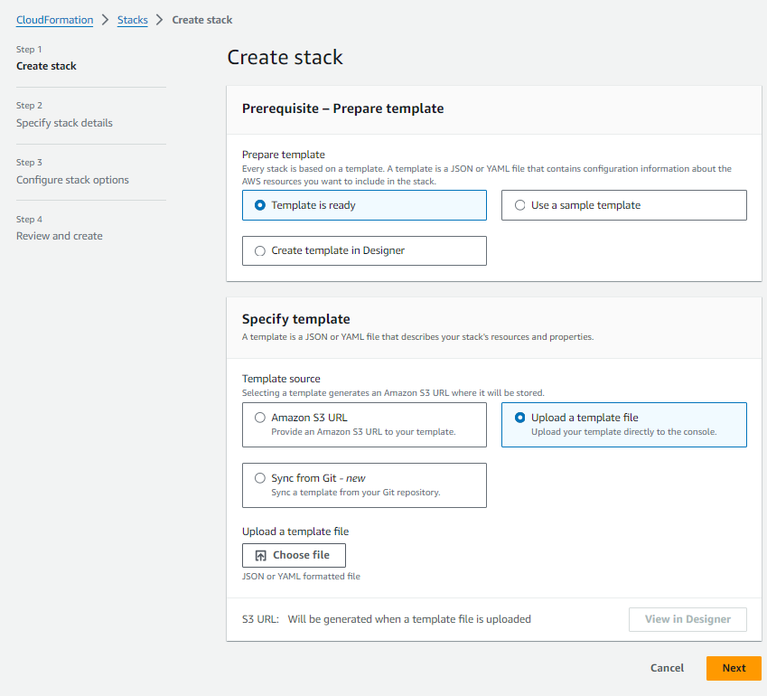

4.Click choose file ..

* Copy file from below link and save it as YAML and choose that file.
* <https://github.com/SRIDEVI24/Projects/blob/fae953d44bd9b4431b2c223e9800ac882ab0bbd1/AWS%20Projects/CLOUD%20FORMATION/ec2-simple_1.yaml>

OR

* Copy the below code and save it as .yaml file

Resources:

  #  EC2 instance of type t2.micro

  CloudFormedEC21A:

    Type: 'AWS::EC2::Instance'

    Properties:

      InstanceType: t2.micro

      ImageId: ami-0c101f26f147fa7fd

      AvailabilityZone: us-east-1a

      Tags:

       - Key: Name

         Value: CloudFormed-ec2-1A

       - Key: Application

         Value:

          Ref: "AWS::StackName"

# output important values for easy viewing in cloudformation dashboard

Outputs:

  InstanceId1A:

    Description: InstanceId of the first EC2 instance

    Value: !Ref CloudFormedEC21A

5.Choose file and click next

6. Provide stack name

7.Continue with default options and create Stack

8. Stack Name >Events

10. Output

11.AWS Console > Ec2 instance > Find the Ec2 instance created as specified in the .YAML file

Please note the tags of the EC2 instances

12.Delete stack and the created EC2 instance will also be deleted.

EC2 instance will also be deleted

But, the YAML file stored in S3 have to be deleted manually.

